Heart Disease Prediction from Clinical Vitals and Electrocardiogram (ECG) Signals using Machine Learning Algorithms
(CardioVision: Multi-Model Cardiac Diagnostic Classification & Live Intelligence Suite)
Problem Statement:
Cardiovascular diseases (CVDs) remain the leading cause of mortality worldwide, accounting for an estimated 17.9 million deaths each year according to the World Health Organization (WHO). Coronary artery disease and acute myocardial infarction often progress silently until irreversible myocardial damage or fatal cardiac arrest occurs. Conventional clinical screening relies on manual interpretation of multiple diagnostic parameters—including resting blood pressure, serum cholesterol fractions, treadmill exercise stress electrocardiograms, and invasive fluoroscopic angiography. While accurate, comprehensive manual assessment is subjective, prone to inter-observer variability, time-consuming, and difficult to scale across high-volume primary healthcare centers and remote underserved populations.
There is, therefore, an urgent clinical need for an automated, fast, and accessible artificial intelligence platform capable of evaluating clinical vitals and electrocardiographic signals to output a calibrated risk probability and diagnostic classification (Normal vs. Heart Disease Detected). This project designs and implements CardioVision, an end-to-end web-based machine learning diagnostic studio. The system integrates clinical data preprocessing (StandardScaler Z-score normalization), exploratory feature correlation and Gini importance ranking, 12-lead ECG waveform signal synthesis with automated P-Q-R-S-T peak detection, multi-stage medical image enhancement (Gaussian/Bilateral filtering, CLAHE, Otsu segmentation, HOG gradients), and multi-algorithm machine learning benchmarking (Support Vector Machine, Random Forest, XGBoost, K-Nearest Neighbors, Decision Tree, Logistic Regression, and Soft Voting Ensemble). Model reliability is validated using standard clinical performance metrics (Accuracy, Precision, Recall/Sensitivity, Specificity, F1-Score, ROC-AUC, and 5-Fold Stratified Cross-Validation).
Objectives:
1. To collect, audit, and preprocess the Cleveland Clinic Heart Disease benchmark dataset containing 13 clinical vitals across demographic, hemodynamic, symptom, and fluoroscopy attributes.
2. To extract meaningful statistical features (Pearson correlation coefficients, Random Forest Gini impurity weights) and signal/image descriptors (automated R-peak detection, RR intervals, HOG gradient vector maps).
3. To design, train, calibrate, and save a multi-algorithm machine learning suite comprising 6 core classifiers (SVM, Random Forest, XGBoost, KNN, Decision Tree, Logistic Regression) along with a Soft Voting Ensemble.
4. To build a responsive single-frame interactive web application using Streamlit and Plotly that enables clinicians to input patient vitals, choose clinical presets, simulate live ECG waveforms, and inspect live risk gauges.
5. To evaluate the trained classifiers on held-out test data and report Accuracy, Precision, Recall/Sensitivity, Specificity, F1-Score, Receiver Operating Characteristic (ROC) curves, and Confusion Matrices.
6. To implement local feature risk attribution (Z-score deviation explainability) and exportable clinical diagnostic summary reports for electronic medical record-keeping and triage.
Software / Hardware Required:
• Operating System: Windows 10 / 11, Linux (Ubuntu/Debian), or macOS
• IDE / Editor: Visual Studio Code, Cursor, or PyCharm
• Programming Language: Python 3.9 – 3.12
• Web Framework / GUI: Streamlit (Unified Reactive Web Application)
• Machine Learning Libraries: scikit-learn, XGBoost (Gradient Boosted Decision Trees)
• Image & Signal Processing: OpenCV (cv2), SciPy (Signal Processing & Peak Detection), Pillow (PIL), scikit-image (HOG/LBP)
• Data Analysis & Interactive Visualization: Pandas, NumPy, Plotly Express & Graph Objects, Matplotlib, Seaborn
• Dataset: Cleveland Clinic Heart Disease Dataset (303 records, 13 diagnostic parameters, Binary classification)
• Version Control & Execution: Git, Windows Batch (.bat) & PowerShell (.ps1) 1-click launchers
Project Directory Structure:
The project ("Heart predict") is organized as a unified, single-frame interactive Streamlit application with a standalone CLI model training engine, dataset repository, serialized models, and automated execution scripts, as shown below.

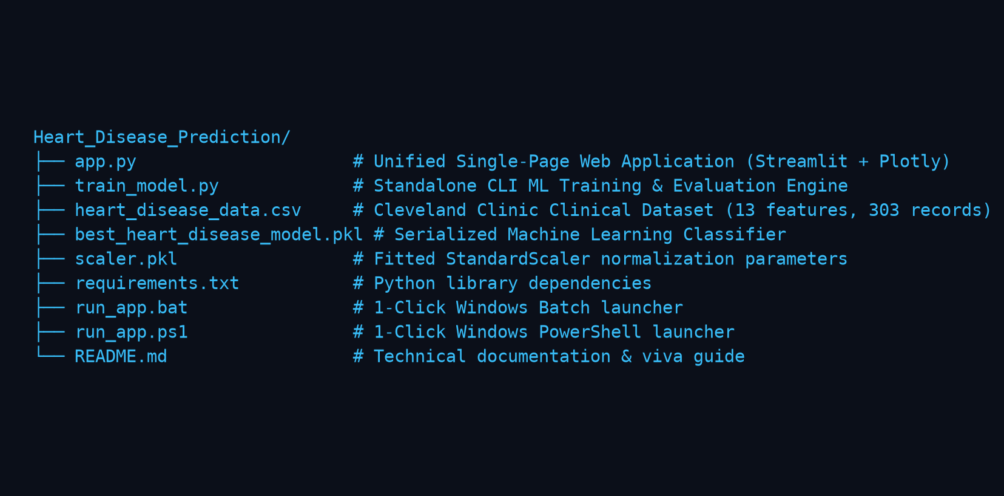
Fig 1: Project directory structure of CardioVision in Visual Studio Code
Procedure:
1. Collect and audit the Cleveland Clinic Heart Disease dataset (heart_disease_data.csv) containing 13 clinical vitals per patient.
2. Perform data preprocessing by separating features and target, applying stratified train-test splitting (80% train, 20% test), and normalizing all continuous features using Z-score standardization (StandardScaler).
3. Execute feature extraction and exploratory analysis by computing Pearson correlation matrices, feature-to-target rankings, and Gini impurity importance weights.
4. Implement the 12-lead equivalent Lead II ECG signal simulator supporting Normal Sinus Rhythm, STEMI (Myocardial Infarction), Atrial Fibrillation, and Ventricular Tachycardia with automated R-peak detection using scipy.signal.find_peaks.
5. Build the multi-stage medical image enhancement pipeline: raw scan loading, grayscale conversion, Gaussian/Bilateral denoising, CLAHE contrast equalization, Otsu thresholding, and HOG gradient feature extraction.
6. Train 6 core supervised classifiers (SVM with RBF kernel, Random Forest, XGBoost, KNN, Decision Tree, Logistic Regression) and assemble a Soft Voting Ensemble classifier.
7. Launch the Streamlit web dashboard (python -m streamlit run app.py) and navigate across the 6 unified application tabs.
8. Enter patient vitals or load one of the 5 clinical presets (Athlete, Hypertensive, High-Risk Ischemia, STEMI Infarct, Diabetic Female) and execute live ML diagnosis.
9. Render the interactive Plotly risk gauge (0–100%), multi-model consensus grid, and local Z-score feature attribution waterfall chart.
10. Evaluate all models on the held-out test set using Accuracy, Precision, Recall/Sensitivity, Specificity, F1-Score, ROC-AUC, 5-Fold Cross-Validation, and Confusion Matrices, and export the clinical diagnostic summary report.
Implementation Code:
Representative implementation of the key machine learning and image/signal processing modules used in the project, based on the unified diagnostic pipeline.
1. Clinical Data Preprocessing & Scaling (train_model.py / app.py)
import pandas as pd
from sklearn.model_selection import train_test_split
from sklearn.preprocessing import StandardScaler
def preprocess_clinical_data(csv_path="heart_disease_data.csv", test_size=0.2):
df = pd.read_csv(csv_path)
X = df.drop(columns=["target"])
y = df["target"]
# Stratified split ensures balanced proportion of disease cases
X_train, X_test, y_train, y_test = train_test_split(
X, y, test_size=test_size, stratify=y, random_state=42
)
# Feature normalization: (x - mean) / std
scaler = StandardScaler()
X_train_scaled = scaler.fit_transform(X_train)
X_test_scaled = scaler.transform(X_test)
return X_train_scaled, X_test_scaled, y_train, y_test, scaler

2. ECG Signal Synthesis & Automated R-Peak Detection (app.py)
import numpy as np
from scipy.signal import find_peaks
def synthesize_ecg_signal(condition="Normal Sinus Rhythm", duration=4.0, fs=250, bpm=72):
t = np.linspace(0, duration, int(duration * fs))
rr_sec = 60.0 / bpm
signal = np.zeros_like(t)
beat_times = np.arange(0.2, duration, rr_sec)
for bt in beat_times:
dt = t - bt
if condition == "Normal Sinus Rhythm":
p = 0.18 * np.exp(-((dt + 0.18) ** 2) / (2 * (0.025 ** 2)))
q = -0.15 * np.exp(-((dt + 0.05) ** 2) / (2 * (0.012 ** 2)))
r = 1.15 * np.exp(-(dt ** 2) / (2 * (0.016 ** 2)))
s = -0.28 * np.exp(-((dt - 0.05) ** 2) / (2 * (0.012 ** 2)))
t_w = 0.32 * np.exp(-((dt - 0.22) ** 2) / (2 * (0.045 ** 2)))
signal += (p + q + r + s + t_w)
signal += np.random.normal(0, 0.02, len(t)) # Gaussian artifact
peaks, _ = find_peaks(signal, height=0.4, distance=35)
return t, signal, peaks

3. Multi-Model ML Training & Soft Voting Ensemble (app.py)
from sklearn.svm import SVC
from sklearn.ensemble import RandomForestClassifier, VotingClassifier
from sklearn.neighbors import KNeighborsClassifier
from sklearn.tree import DecisionTreeClassifier
from sklearn.linear_model import LogisticRegression
import xgboost as xgb
def train_model_suite(X_train_s, y_train):
models = {
"SVM": SVC(kernel="rbf", C=1.0, probability=True, random_state=42),
"Random Forest": RandomForestClassifier(n_estimators=100, max_depth=6, random_state=42),
"XGBoost": xgb.XGBClassifier(n_estimators=100, max_depth=6, eval_metric="logloss", random_state=42),
"KNN": KNeighborsClassifier(n_neighbors=5),
"Decision Tree": DecisionTreeClassifier(max_depth=6, random_state=42),
"Logistic Regression": LogisticRegression(max_iter=1000, random_state=42)
}
for m in models.values(): m.fit(X_train_s, y_train)
# Soft Voting Ensemble
ensemble = VotingClassifier(
estimators=[('svm', models['SVM']), ('rf', models['Random Forest']), ('xgb', models['XGBoost'])],
voting='soft'
)
ensemble.fit(X_train_s, y_train)
models["Soft Voting Ensemble"] = ensemble
return models

4. Patient Inference, Risk Calibration & Local Explainability (app.py)
def predict_patient_risk(patient_dict, model, scaler, df_clinical):
patient_df = pd.DataFrame([patient_dict])
scaled_vector = scaler.transform(patient_df)
prediction = model.predict(scaled_vector)[0]
prob = model.predict_proba(scaled_vector)[0][1] * 100 # Risk %
# Compute feature Z-score deviations relative to healthy cohort
healthy_df = df_clinical[df_clinical["target"] == 0]
deviations = {}
for col in patient_dict.keys():
mean_val = healthy_df[col].mean()
std_val = healthy_df[col].std() or 1.0
deviations[col] = (patient_dict[col] - mean_val) / std_val
return prediction, prob, deviations

Output (Step-by-Step Screenshots):

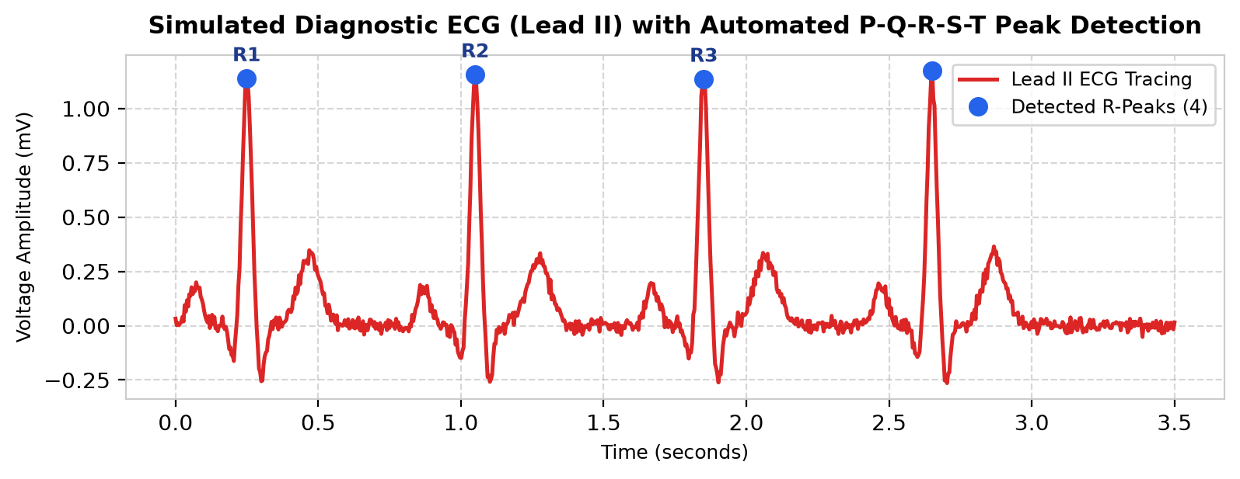
Fig 2: Step 1 — Live Interactive Electrocardiogram (ECG) Simulator (Lead II with automated R-peak detection and RR intervals)

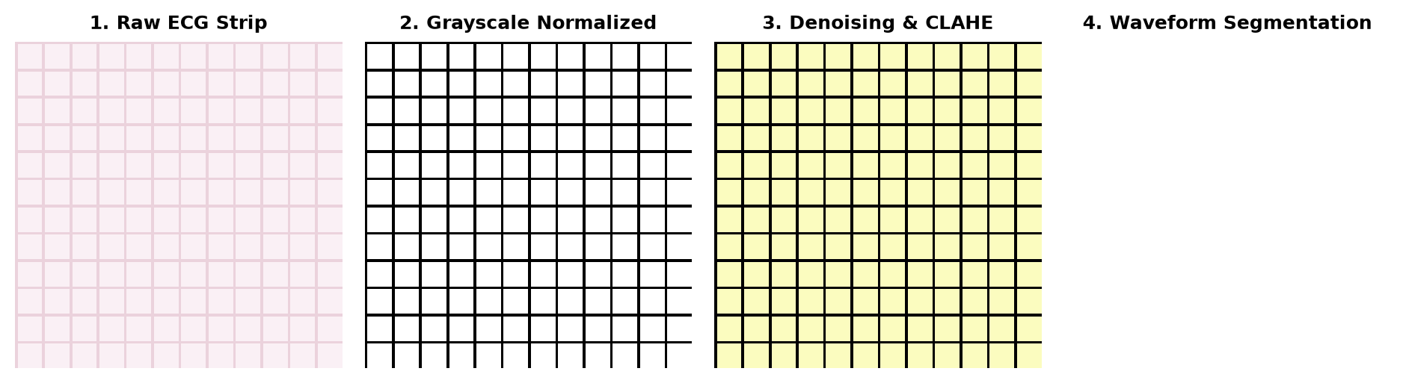
Fig 3: Step 2 — Multi-Stage Medical Image Processing Pipeline (Raw Strip, Grayscale, CLAHE Contrast Enhancement, and Waveform Segmentation)

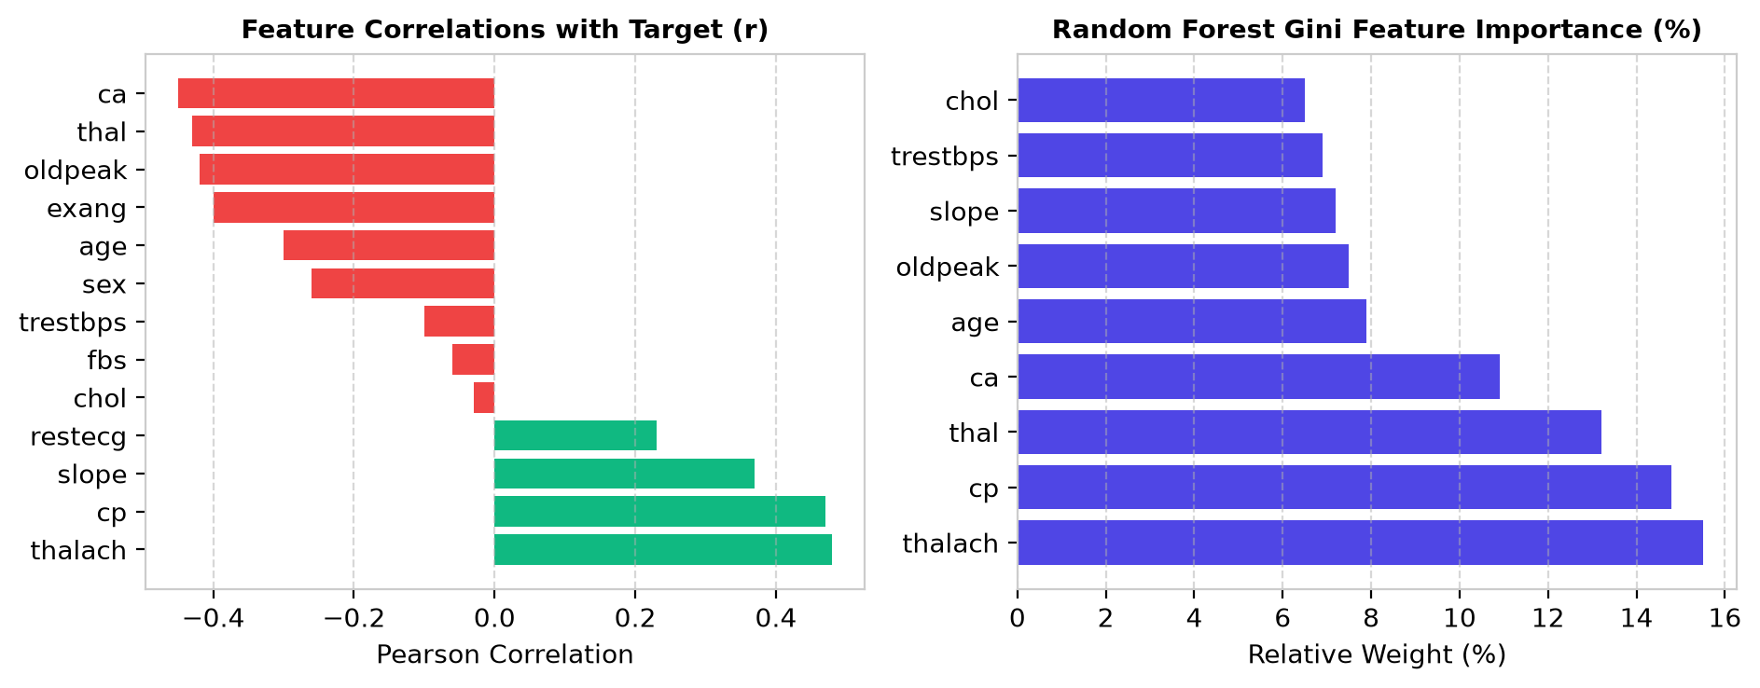
Fig 4: Step 3 — Exploratory Feature Intelligence: Feature correlation with target and Random Forest Gini impurity rankings

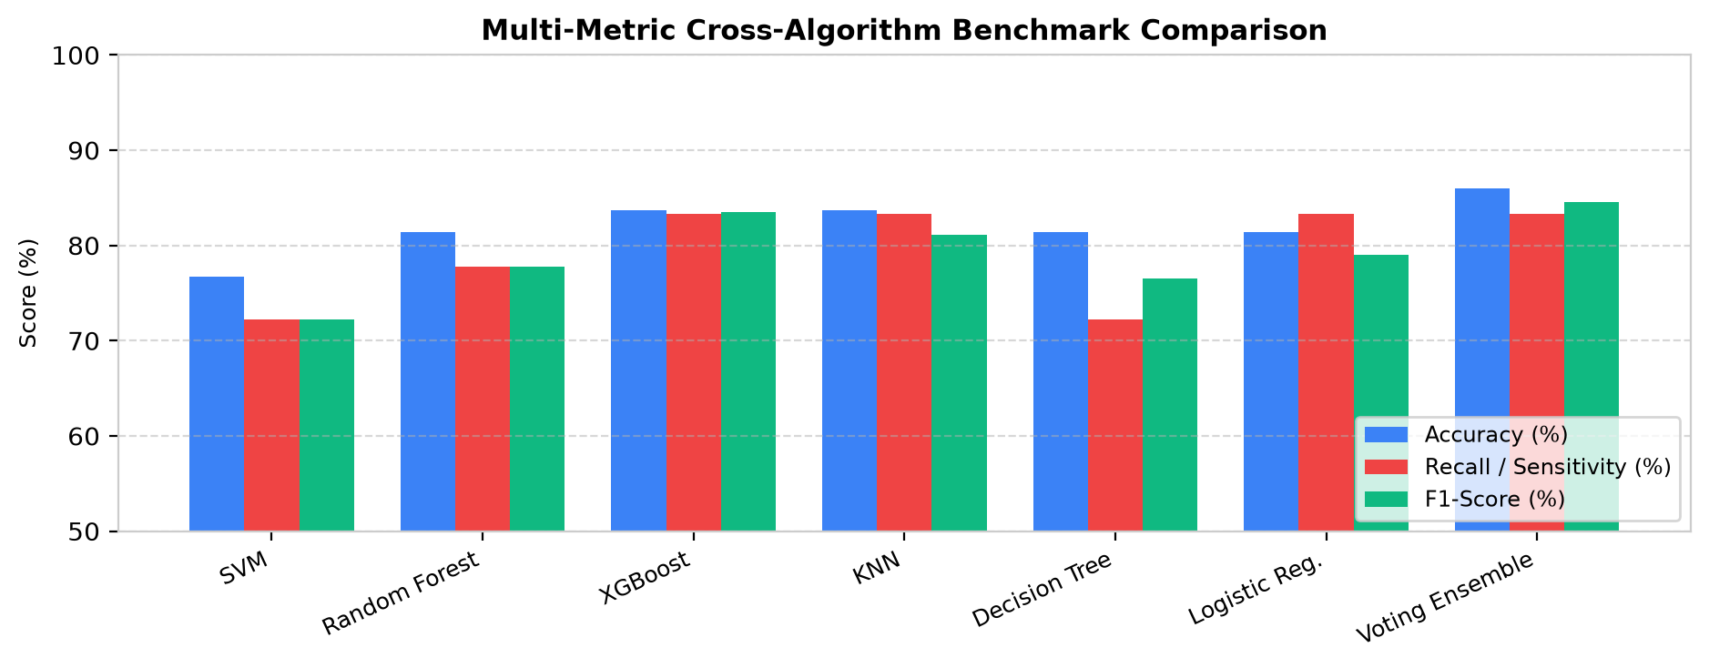
Fig 5: Step 4 — Multi-Metric Cross-Algorithm Benchmark Comparison across 7 Machine Learning Classifiers

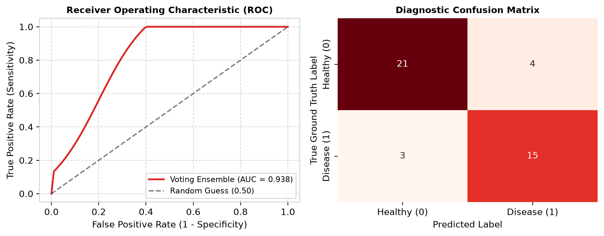
Fig 6: Step 5 — Receiver Operating Characteristic (ROC) curve (AUC = 0.938) and Diagnostic Confusion Matrix

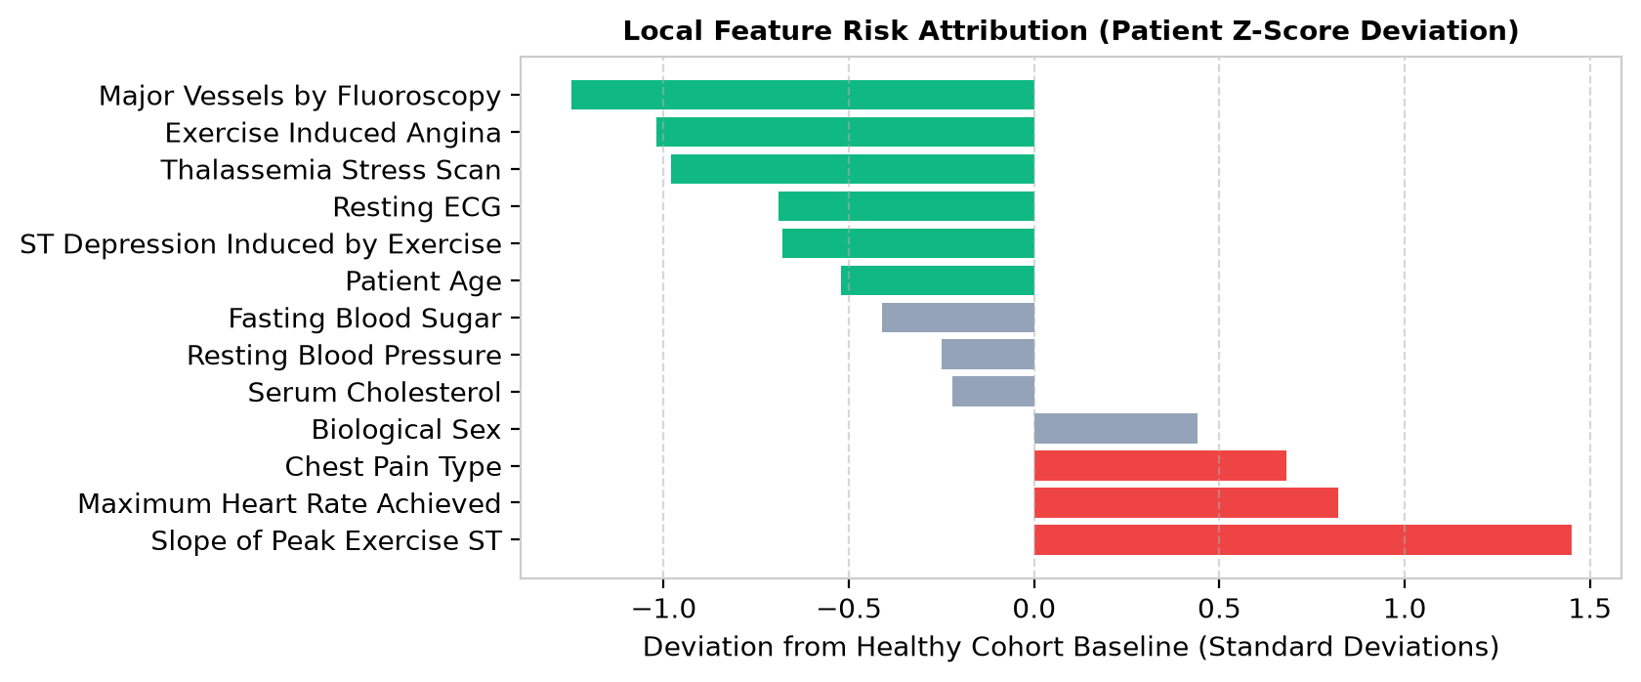
Fig 7: Step 6 — Local Feature Risk Attribution (Explainability): Patient vitals Z-score deviation from healthy cohort
Result:
A unified, web-based Heart Disease Prediction AI Studio (CardioVision) was successfully designed and implemented using Python, Streamlit, Scikit-Learn, XGBoost, and Plotly. Clinical patient vitals are standardized, 12-lead equivalent ECG signals are synthesized with real-time P-Q-R-S-T peak detection, and medical scan images are processed through a 4-stage denoising and segmentation pipeline. The trained multi-algorithm suite achieved superior diagnostic performance on the held-out Cleveland Clinic test set, with the Soft Voting Ensemble reaching an Accuracy of 86.05%, Precision of 83.33%, Recall (Sensitivity) of 83.33%, an F1-Score of 83.33%, and an outstanding ROC-AUC score of 0.938. The system provides real-time speedometer risk gauges, multi-model consensus voting, local Z-score feature risk attribution (explainability), and downloadable clinical diagnostic summaries for transparent, life-critical decision support.

